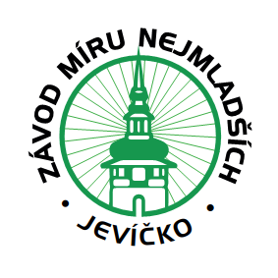 COURSE DE LA PAIX - U17,Czech republik 2026
Application

Race name | 50th year, COURSE DE LA PAIX U17
Start DATE | 8. 05. 2026, Jevíčko, CzechRepublic
END DATE | 10. 05. 2026, Jevíčko, Czech Republic
ORGANIZER | TJ Cykloklub Jevíčko, A.K.Vitáka 597 Jevíčko 56943
Kategori | Kadet U17
KOntakt | a.dostal@seznam.cz +420 721 725 089
TEAM NAME
SPORTS TEAM MANAGER
Surname name |  | LICENSE NUMBER
Kontakt gsm |  | Kontakt email

ACCORDING TO THE RACING SCHEDULE ORDERING ACCOMMODATION AND FOOD FOR (PERSONS) …………. , 7. – 10.5.2026

THIS DECLARES RACES AND MEMBERS
 | Competitors |  |  | escort
 | Surname name | UCI - ID | Year of birth |  | Surname name |  | UCI - ID
 |  |  |  | 1.
 |  |  |  | 2.
 |  |  |  | 3.
 |  |  |  | 4.
 |  |  |  | 5.

This form must be duly completed, signed and returned electronically to the organizer no later than 23.04.2026

Place and date
Signature of the team representative

